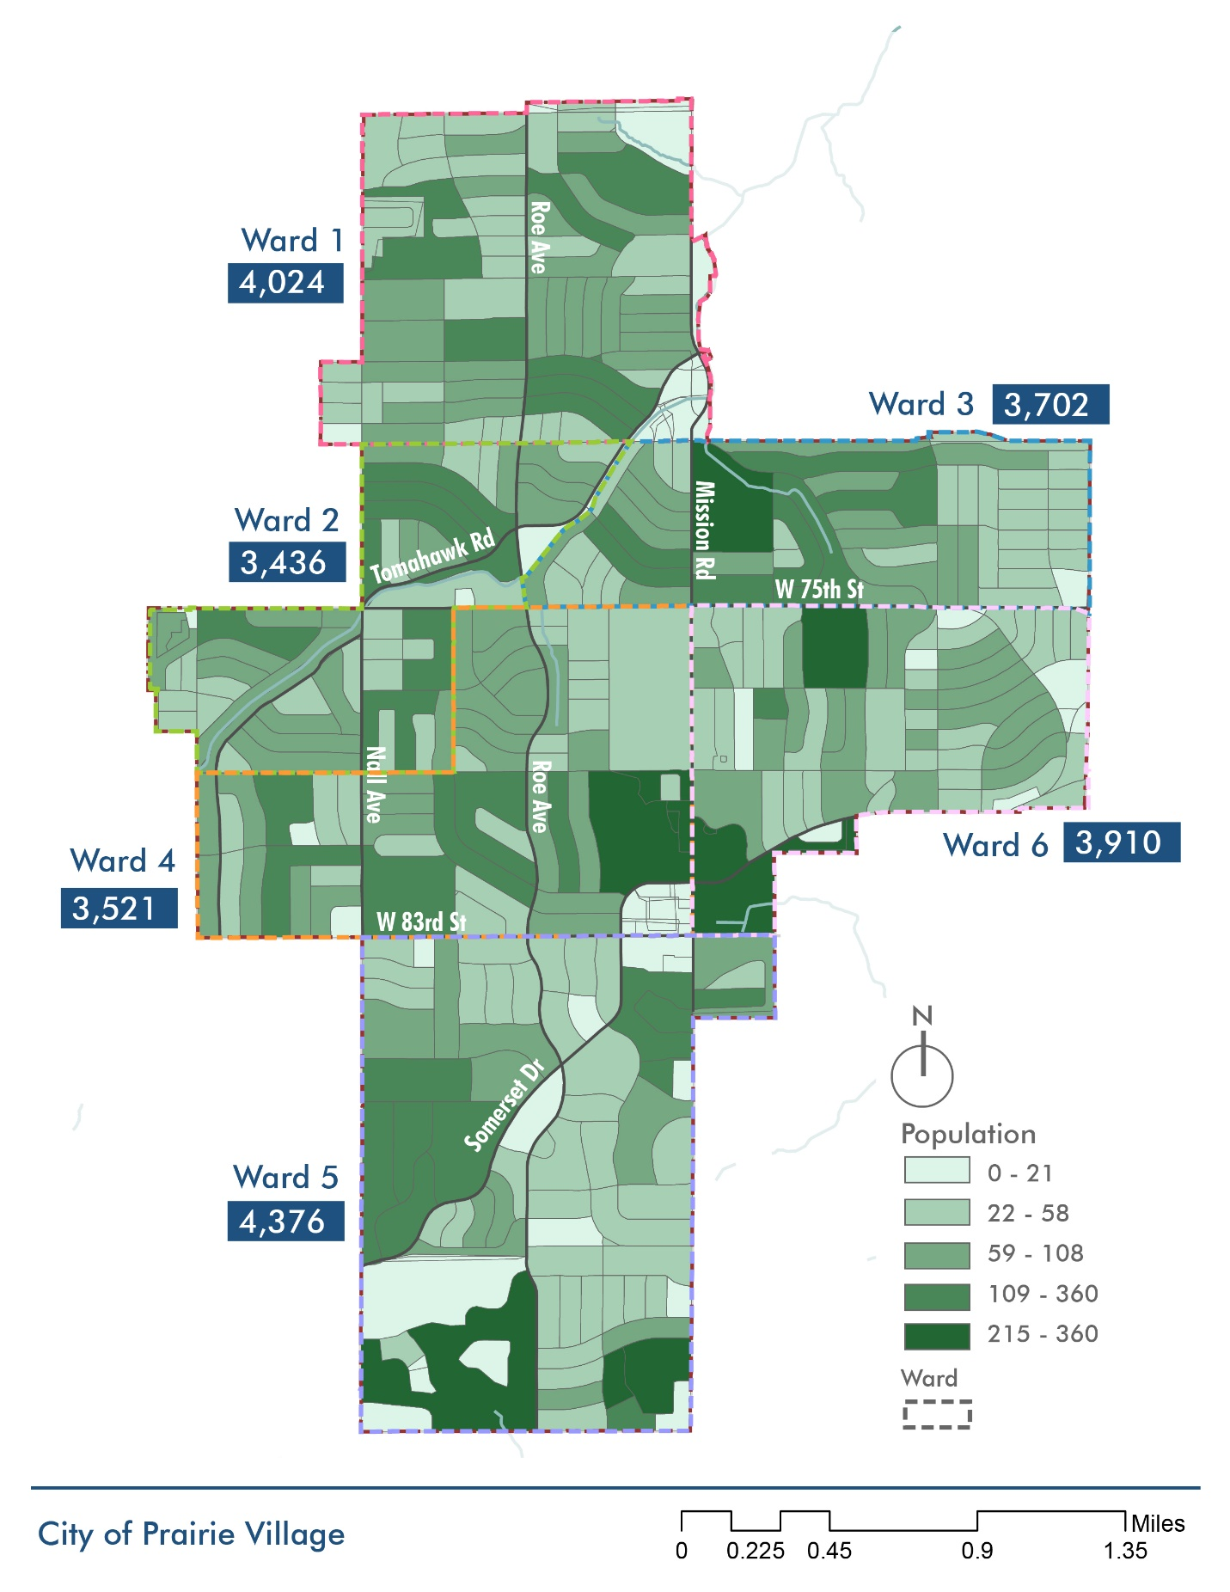
2010 Ward 6 Population: 3,780 – increased 3.4%
2010 Ward 5 Population: 3,619 – increased 21%
2010 Ward 4 Population: 3,383 – increased 4.1%
2010 Ward 2 Population: 3,338 – increased 2.9%
2010 Ward 1 Population: 3,859 – increased 4.3%
2010 Ward 3 Population: 3,468 – increased 6.7%

